Deployment Manager - Full Production

[favorite_border](https://www.qwiklabs.com/favorite.json?item_id=981&item_type=CatalogItem)

Add to favorites

help

—/100

Checkpoints

arrow_forward

Deploy the application

Check my progress

/ 50

Configure an uptime check and alert policy in Cloud Monitoring

Check my progress

/ 25

Create a test VM with ApacheBench

Check my progress

/ 25

Start Lab

01:30:00

[GSP060](https://www.qwiklabs.com/focuses/981?parent=catalog#step1)[Overview](https://www.qwiklabs.com/focuses/981?parent=catalog#step2)[Objectives](https://www.qwiklabs.com/focuses/981?parent=catalog#step3)[Setup and Requirements](https://www.qwiklabs.com/focuses/981?parent=catalog#step4)[Create a virtual environment](https://www.qwiklabs.com/focuses/981?parent=catalog#step5)[Clone the Deployment Manager Sample Templates](https://www.qwiklabs.com/focuses/981?parent=catalog#step6)[Explore the Sample Files](https://www.qwiklabs.com/focuses/981?parent=catalog#step7)[Customize the Deployment](https://www.qwiklabs.com/focuses/981?parent=catalog#step8)[Run the Application](https://www.qwiklabs.com/focuses/981?parent=catalog#step9)[Verify that the application is operational](https://www.qwiklabs.com/focuses/981?parent=catalog#step10)[Configure an uptime check and alert policy in Cloud Monitoring](https://www.qwiklabs.com/focuses/981?parent=catalog#step11)[Configure an alerting policy and notification](https://www.qwiklabs.com/focuses/981?parent=catalog#step12)[Configure a Dashboard with a Couple of Useful Charts](https://www.qwiklabs.com/focuses/981?parent=catalog#step13)[Create a test VM with ApacheBench](https://www.qwiklabs.com/focuses/981?parent=catalog#step14)[Simulate a Service Outage](https://www.qwiklabs.com/focuses/981?parent=catalog#step15)[Test your knowledge](https://www.qwiklabs.com/focuses/981?parent=catalog#step16)[Congratulations!](https://www.qwiklabs.com/focuses/981?parent=catalog#step17)[Finish your Quest](https://www.qwiklabs.com/focuses/981?parent=catalog#step18)

Deployment Manager - Full Production

1 hour 30 minutes9 Credits

Rate Lab

**GSP060**



**Overview**

In this lab, you launch a service using an infrastructure orchestration tool called Deployment Manager and monitor the service using Cloud Monitoring. In Cloud Monitoring, you set up basic black box monitoring with a Cloud Monitoring dashboard and establish an Uptime Check (alert notification) to trigger incident response.

More specifically, you:

1. Install and configure an advanced deployment using Deployment Manager sample templates.
2. Enable Cloud Monitoring.
3. Configure Cloud Monitoring Uptime Checks and notifications.
4. Configure a Cloud Monitoring dashboard with two charts, one showing CPU usage and the other ingress traffic.
5. Perform a load test and simulate a service outage.

Cloud Monitoring provides visibility into the performance, uptime, and overall health of cloud-powered applications.It collects metrics, events, and metadata from Google Cloud, Amazon Web Services, hosted uptime probes, application instrumentation, and a variety of common application components including Cassandra, Nginx, Apache Web Server, Elasticsearch, and many others. Cloud Monitoring ingests that data and generates insights via dashboards, charts, and alerts. Cloud Monitoring alerting helps you collaborate by integrating with Slack, PagerDuty, HipChat, Campfire, and more.

**Objectives**

In this lab, you learn to:

* Launch a cloud service from a collection of templates.
* Configure basic black box monitoring of an application.
* Create an uptime check to recognize a loss of service.
* Establish an alerting policy to trigger incident response procedures.
* Create and configure a dashboard with dynamically updated charts.
* Test the monitoring and alerting regimen by applying a load to the service.
* Test the monitoring and alerting regimen by simulating a service outage.

**Setup and Requirements**

**Before you click the Start Lab button**

Read these instructions. Labs are timed and you cannot pause them. The timer, which starts when you click **Start Lab**, shows how long Google Cloud resources will be made available to you.

This Qwiklabs hands-on lab lets you do the lab activities yourself in a real cloud environment, not in a simulation or demo environment. It does so by giving you new, temporary credentials that you use to sign in and access Google Cloud for the duration of the lab.

**What you need**

To complete this lab, you need:

* Access to a standard internet browser (Chrome browser recommended).
* Time to complete the lab.

**Note:** If you already have your own personal Google Cloud account or project, do not use it for this lab.

**Note:** If you are using a Pixelbook, open an Incognito window to run this lab.

**How to start your lab and sign in to the Google Cloud Console**

1. Click the **Start Lab** button. If you need to pay for the lab, a pop-up opens for you to select your payment method. On the left is a panel populated with the temporary credentials that you must use for this lab.

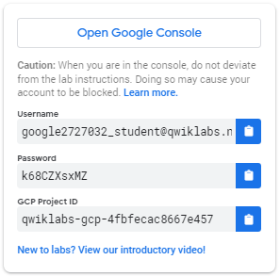

1. Copy the username, and then click **Open Google Console**. The lab spins up resources, and then opens another tab that shows the **Sign in** page.

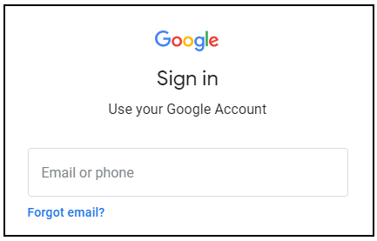

***Tip:*** Open the tabs in separate windows, side-by-side.

If you see the **Choose an account** page, click **Use Another Account**. 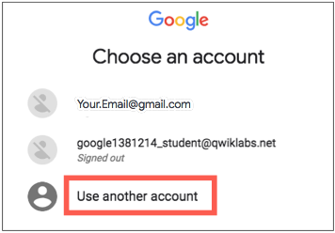

1. In the **Sign in** page, paste the username that you copied from the Connection Details panel. Then copy and paste the password.

***Important:*** You must use the credentials from the Connection Details panel. Do not use your Qwiklabs credentials. If you have your own Google Cloud account, do not use it for this lab (avoids incurring charges).

1. Click through the subsequent pages:
   * Accept the terms and conditions.
   * Do not add recovery options or two-factor authentication (because this is a temporary account).
   * Do not sign up for free trials.

After a few moments, the Cloud Console opens in this tab.

**Note:** You can view the menu with a list of Google Cloud Products and Services by clicking the **Navigation menu** at the top-left. 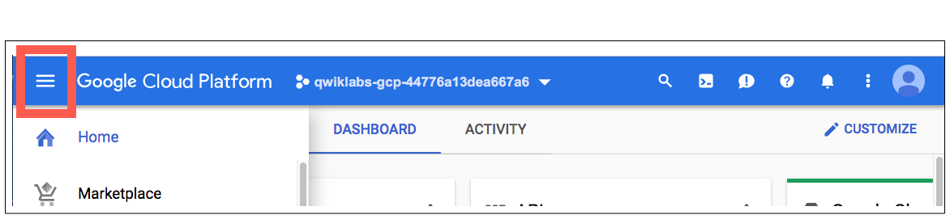

Activate Cloud Shell

Cloud Shell is a virtual machine that is loaded with development tools. It offers a persistent 5GB home directory and runs on the Google Cloud. Cloud Shell provides command-line access to your Google Cloud resources.

In the Cloud Console, in the top right toolbar, click the **Activate Cloud Shell** button.

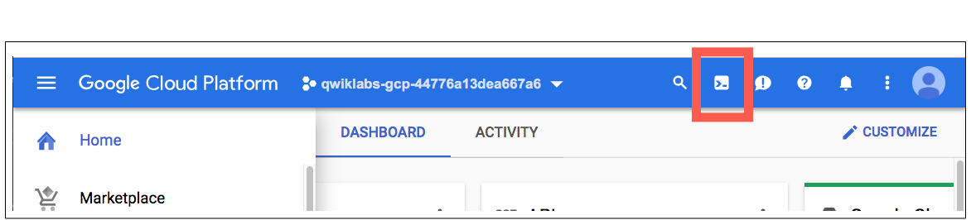

Click **Continue**.

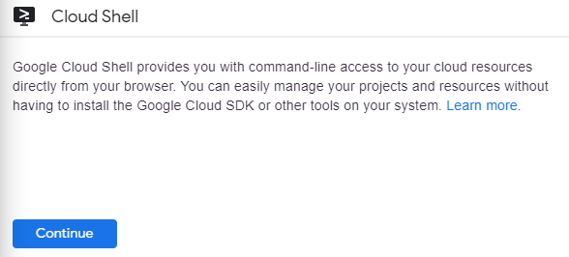

It takes a few moments to provision and connect to the environment. When you are connected, you are already authenticated, and the project is set to your *PROJECT_ID*. For example:

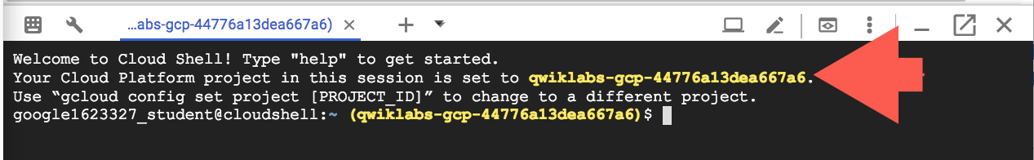

gcloud is the command-line tool for Google Cloud. It comes pre-installed on Cloud Shell and supports tab-completion.

You can list the active account name with this command:

gcloud auth list

(Output)

Credentialed accounts:

- <myaccount>@<mydomain>.com (active)

(Example output)

Credentialed accounts:

- google1623327_student@qwiklabs.net

You can list the project ID with this command:

gcloud config list project

(Output)

[core]

project = <project_ID>

(Example output)

[core]

project = qwiklabs-gcp-44776a13dea667a6

For full documentation of gcloud see the [gcloud command-line tool overview](https://cloud.google.com/sdk/gcloud).

**Create a virtual environment**

Execute the following command to download and update the packages list.

sudo apt-get update

Python virtual environments are used to isolate package installation from the system.

sudo apt-get install virtualenv

If prompted [Y/n], press Y and then Enter.

virtualenv -p python3 venv

Activate the virtual environment.

source venv/bin/activate

**Clone the Deployment Manager Sample Templates**

Google provides a robust set of sample Deployment Manager templates that you can learn from and build upon.

To clone the repository, enter the following commands in Cloud Shell Command Line to create a directory to hold the Deployment Manager sample templates.

mkdir ~/dmsamples

Go to that directory.

cd ~/dmsamples

Clone the repository to the directory you just made.

git clone https://github.com/GoogleCloudPlatform/deploymentmanager-samples.git

**Example Output:**

remote: Counting objects: 1917, done.

remote: Compressing objects: 100% (31/31), done.

remote: Total 1917 (delta 11), reused 29 (delta 7), pack-reused 1874

Receiving objects: 100% (1917/1917), 426.86 KiB | 0 bytes/s, done.

Resolving deltas: 100% (1060/1060), done.

**Explore the Sample Files**

We just downloaded a collection of sample templates to our directory, let's dive in and explore some of them.

List the example templates

Run the following commands to navigate to and list the version2 examples:

cd ~/dmsamples/deploymentmanager-samples/examples/v2

ls

You should see something like this:

access_context_manager cloud_functions common folder_creation iam_custom_role internal_lb_haproxy quick_start ssl vm_with_disks

access_control cloudkms container_igm gke igm-updater metadata_from_file regional_igm step_by_step_guide vpn_auto_subnet

bigtable cloud_router container_vm ha-service image_based_igm nodejs saltstack template_modules waiter

build_configuration cloudsql custom_machine_type htcondor instance_pool nodejs_l7 single_vm vlan_attachment

cloudbuild cloudsql_import dataproc iam internal_lb project_creation sqladmin vm_startup_script

Not all of the subdirectories are independent projects. For example, the directory named **common** contains templates that are used by several of the other projects. If you are studying independently later, use the README files as a guide.

The nodejs directory contains everything you need to build this lab. Note that there is a nodejs directory and a nodejs_l7directory. Use nodejs.

List and examine the Nodejs deployment

Navigate to and list the version2 examples:

cd nodejs/python

ls

**Example Output:**

frontend.py frontend.py.schema nodejs.py nodejs.py.schema nodejs.yaml

The main deployment manager configuration file is nodejs.yaml. It makes use of templates to generate infrastructure. The rest of the files are templates. Templates use variables defined in the nodejs.yaml configuration file to produce customized results.

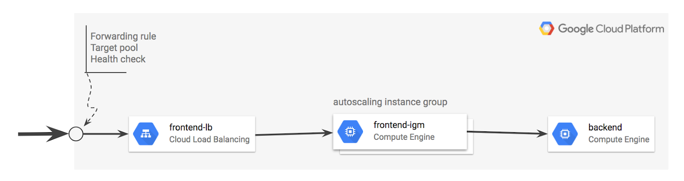

frontend.py

frontend.py includes frontend.py.schema, which creates an instance template based on container_instance_template.py. This template is used to create a managed instance group and an autoscaler. The template also creates a network load balancer that has a forwarding rule with a single public IP address. It also creates:

* A target pool that refers to the managed instance group.
* A health check attached to the target pool.

nodejs.py

nodejs.py includes nodejs.py.schema, which brings the frontend and backend templates together.

* Note that the frontend is frontend.py.
* The backend is /common/python/container_vm.py.
* This is a VM running a Docker container with MySQL, so it doesn't require a custom template.

Other files

* /common/python/container_instance_template.py
* /common/python/container_vm.py
* /common/python/container_helper.py

**Customize the Deployment**

Now that you've downloaded and reviewed the nodejs Deployment Manager template, let's start customizing the deployment.

Specify the zone

The nodejs.yaml file requires a zone, and you'll now add one to the file.

1. Enter the following command to open the list of zones:

gcloud compute zones list

Copy the name of a zone for the configuration file to use.

1. Open nodejs.yaml in nano so you can edit the zone value:

nano nodejs.yaml

The nodejs.yaml file contents:

resources:

- name: nodejs

type: nodejs.py

properties:

zone: ZONE_TO_RUN

1. Replace ZONE_TO_RUN with a zone name that's near you, then exit nano and save the file.

This example shows ZONE_TO_RUN set to us-east1-d

resources:

- name: nodejs

type: nodejs.py

properties:

zone: us-east1-d

Modify the maximum number of instances in the instance group

Edit the nodejs.py file.

1. Enter this command to open nodejs.py in nano:

nano nodejs.py

1. Verify current scaling limit for frontend in nodejs.py

{

'name': frontend,

'type': 'frontend.py',

'properties': {

'zone': context.properties['zone'],

'dockerImage': 'gcr.io/deployment-manager-examples/nodejsservice',

'port': application_port,

# Define the variables that are exposed to container as env variables.

'dockerEnv': {

'SEVEN_SERVICE_MYSQL_PORT': mysql_port,

'SEVEN_SERVICE_PROXY_HOST': '$(ref.' + backend

+ '.networkInterfaces[0].networkIP)'

},

# If left out will default to 1

'size': 2,

# If left out will default to 1

'maxSize': 20

}

},

Current scaling limit is 20 (refer maxSize).

1. Modify the maxSize and set it to 4:

{

'name': frontend,

'type': 'frontend.py',

'properties': {

'zone': context.properties['zone'],

'dockerImage': 'gcr.io/deployment-manager-examples/nodejsservice',

'port': application_port,

# Define the variables that are exposed to container as env variables.

'dockerEnv': {

'SEVEN_SERVICE_MYSQL_PORT': mysql_port,

'SEVEN_SERVICE_PROXY_HOST': '$(ref.' + backend

+ '.networkInterfaces[0].networkIP)'

},

# If left out will default to 1

'size': 2,

# If left out will default to 1

'maxSize': 4

}

},

Save the file and exit nano when you're done.

**Run the Application**

Now you'll use Deployment Manager to deploy the application and make it operational. This builds the infrastructure, but it won't allow traffic. After Deployment Manager sets up the infrastructure, you can apply service labels.

Deploy the application

Enter this command to name the application advanced-configuration and pass Deployment Manager the configuration file (nodejs.yaml).

gcloud deployment-manager deployments create advanced-configuration --config nodejs.yaml

Output:

The fingerprint of the deployment is PiYc6OsIFkWzQpCDklHvaA==

Waiting for create [operation-1529913842103-56f72d31872d9-90070017-aec5761d]...done.

Create operation operation-1529913842103-56f72d31872d9-90070017-aec5761d completed successfully.

NAME TYPE STATE ERRORS INTENT

advanced-configuration-application-fw compute.v1.firewall COMPLETED []

advanced-configuration-backend compute.v1.instance COMPLETED []

advanced-configuration-frontend-as compute.v1.autoscaler COMPLETED []

advanced-configuration-frontend-hc compute.v1.httpHealthCheck COMPLETED []

advanced-configuration-frontend-igm compute.v1.instanceGroupManager COMPLETED []

advanced-configuration-frontend-it compute.v1.instanceTemplate COMPLETED []

advanced-configuration-frontend-lb compute.v1.forwardingRule COMPLETED []

advanced-configuration-frontend-tp compute.v1.targetPool COMPLETED []

Click **Check my progress** below to check your lab progress.

Deploy the application

Check my progress

Confirm the limit for the maximum number of instances:

1. Go to **Compute Engine** > **Instance groups**.

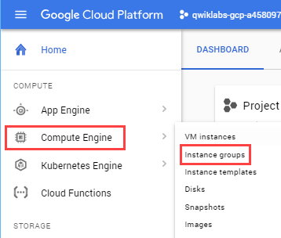

1. Click on **advanced-configuration-frontend-igm**. 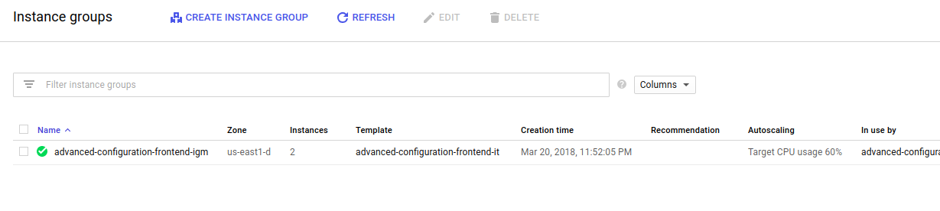
2. Click on the Details tab, then verify the maximum number of instances. 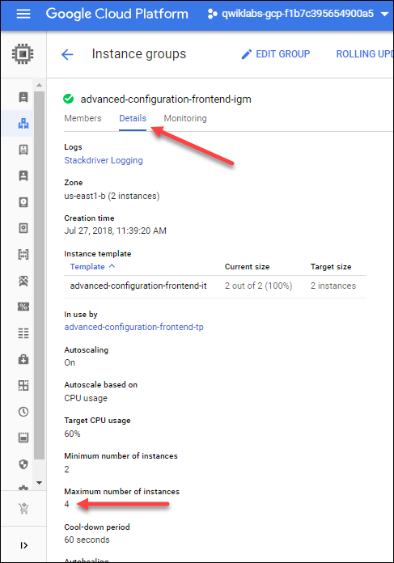

You'll see it has been set to 4.

**Verify that the application is operational**

The application takes a few minutes to start. You can view it in the Deployment Manager part of Cloud Console (**Navigation menu** > **Deployment Manager**), or you can see the instances in the Compute Engine part of Console (**Navigation menu** > **Compute Engine** > **VM**).

To verify that the application is running, open a browser to access port 8080 and view the service. Since the IP address was established dynamically when the Deployment Manager implemented the global forwarding rule (specified in the template), you'll need to find that address to test the application.

Find the global load balancer forwarding rule IP address

1. Enter the following command in the Cloud Command Line to find your forwarding IP address.

gcloud compute forwarding-rules list

**Example output:**

369c66095dd87ce8.png Your forwarding IP address is the IP_ADDRESS listed in your output. Be sure to record it; you'll use it a few times in this lab.

1. Open a new window in your browser. In the address field, enter the following URL, replacing <your IP address> with your forwarding IP address:

http://<your IP address>:8080

You see a blank page, similar to below, with your own IP address:

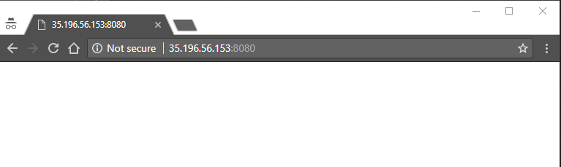

It may take up to 10 minutes for the service to become operational. If you get an error, such as a 404, or a time out, wait about two minutes and try again.

1. Now enter log information by entering a log message in your browser address line.

http://<your forwarding IP address>:8080/?msg=<enter_a_message>

Replace enter_a_message with any kind of message.

These are log message examples - you have a different IP address:

http://35.196.56.153:8080/?msg=my dog has spots

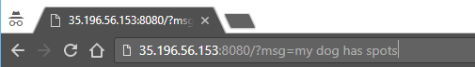

After you enter the log, the browser returns added.

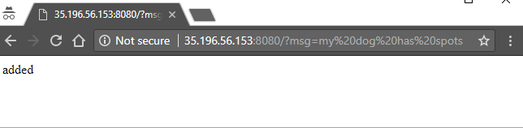

1. View the log by going to http://<your IP address>:8080. For example:

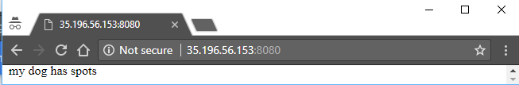

Go ahead and create more logs and see them at http://<your IP address>:8080.

**Configure an uptime check and alert policy in Cloud Monitoring**

Create a Monitoring workspace

Now set up a Monitoring workspace that's tied to your Google Cloud Project. The following steps create a new account that has a free trial of Monitoring.

1. In the Cloud Console, click **Navigation menu** > **Monitoring**.
2. Wait for your workspace to be provisioned.

When the Monitoring dashboard opens, your workspace is ready.

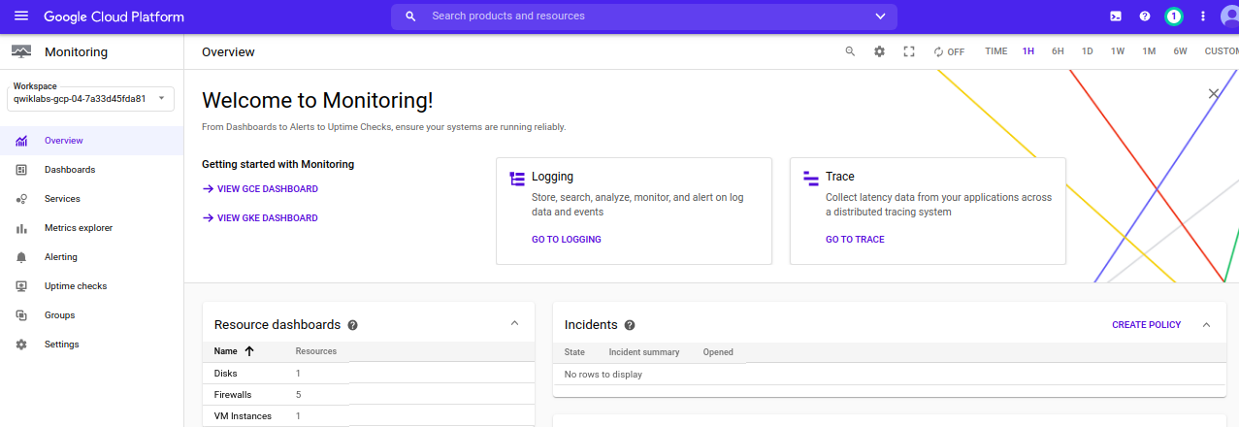

Configure an uptime check

The Cloud Monitoring window opens.

1. In the Cloud Monitoring tab, click on **Uptime Checks**
2. Click **Create Uptime Check**.
3. In the **New uptime check** page Specify the following:

|  |  |
| --- | --- |
| **Property** | **Value** |
| Title | Check1 |
| Check Type | TCP |
| Resource Type | URL |
| Hostname | <your forwarding address> (you previously recorded) |
| Port | 8080 |
| Response content contains the text | <leave blank> |
| Check every | 1 minute |

1. Click **Test** to test the check:

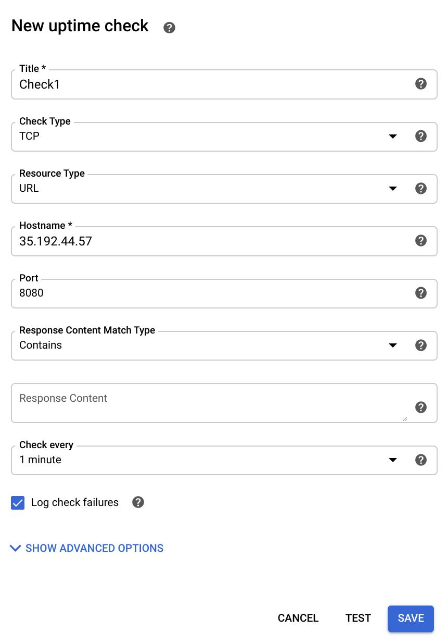

If the test fails, make sure that the service is still working. Also check to see that the firewall rule exists and is correct.

1. After the test succeeds, click **Save**.

After the Uptime Check is saved, Cloud Monitoring offers to create an alerting policy. Click **No, Thanks**.

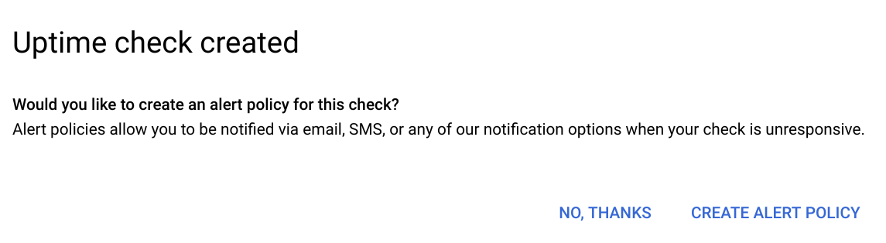

**Configure an alerting policy and notification**

1. Click on **Alerting** > **Create Policy**.
2. Name the policy **Test**.
3. Click **Add Condition**.
4. For **Find resource type and metric**, select **Compute Engine VM Instance**.
5. For **Metrics**, select a metric you are interested in evaluating, such as **CPU usage** or **CPU utilization**.
6. For **Condition**, select **is above**.
7. Specify the threshold value and for how long the metric must cross this set value before the alert is triggered. For example, for **THRESHOLD**, type **20** and set **FOR** to **1 minute**.
8. Click **Add**.
9. In **Notifications**, click on **Add Notification Channel** select Notification Channel type as "Email" and add your personal email. Then Click **Add**.

In a later step, you trigger an event that notify you via email.

1. Click **Save**.

Click **Check my progress** below to check your lab progress.

Configure an Uptime Check and Alert Policy in Cloud Monitoring

Check my progress

**Configure a Dashboard with a Couple of Useful Charts**

Configure a dashboard

1. In the left menu, click **Dashboards** > **Create Dashboard**
2. Name the New Dashboard **DMDash**. and then Click **Confirm**.
3. Click **Add Chart** in the top right.

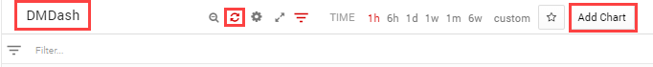

1. Set the following properties:

|  |  |
| --- | --- |
| **Property** | **Value** |
| Title | Sample |
| Resource type | Compute Engine VM Instance |
| Metric Type | CPU Usage |

1. Click **Save**.
2. Click on **Add Chart** to add another chart to the dashboard with the following properties:

|  |  |
| --- | --- |
| **Property** | **Value** |
| Title | Sample 2 |
| Resource type | Compute Engine VM Instance |
| Metric Type | Sent bytes |

1. Click **Save** DMDash should look like this:

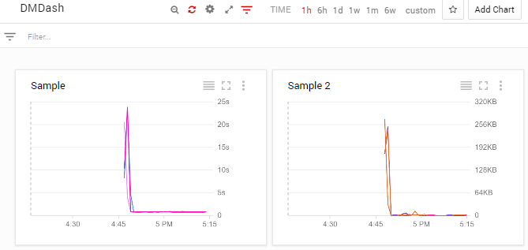

**Create a test VM with ApacheBench**

Now that you've configured monitoring for traffic in a specified region, see if it works. You'll install and use ApacheBench to apply 3 levels of load to the service and then view the Cloud Monitoring Dashboard you've set up.

Create a VM

1. In the Cloud Console, click **Compute Engine** > **VM instances**.

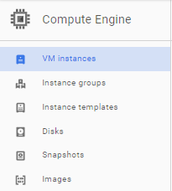

1. Click **Create instance**, use all the default settings in the **Create an instance** dialog.

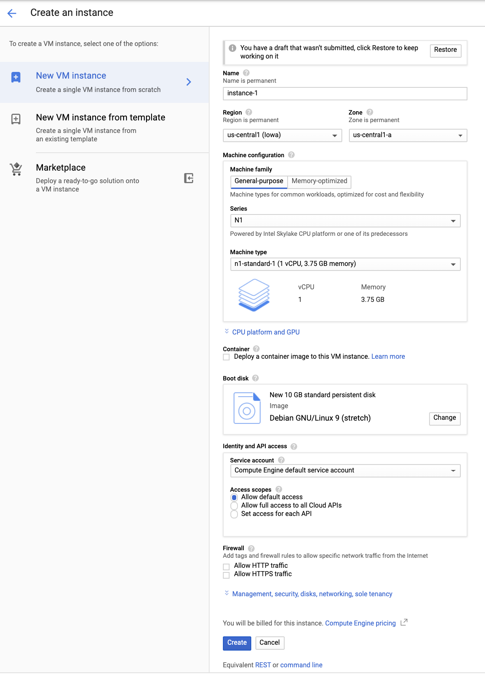

1. Click **Create**.

Install ApacheBench

1. Still in the VM Instances window, click the instance-1 **SSH** button to SSH into the VM you just created.
2. Enter the following commands to install the latest ApacheBench:

sudo apt-get update

sudo apt-get -y install apache2-utils

Click **Check my progress** below to check your lab progress.

Create a Test VM with ApacheBench.

Check my progress

Apply and monitor load

Now you'll use ApacheBench to apply load to the service. Watch the DMDash dashboard in Cloud Monitoring to monitor the CPU usage and the Network Inbound Traffic. You'll also be able to track the number of instances in Cloud Monitoring by mousing over the lines, or by viewing the instances in the Cloud Console (**Navigation menu** > **Compute Engine** > **VM**).

1. In the SSH window, enter this command for ApacheBench to apply load to the service. Replace your forwarding IP for Your_IP (you previously recorded). Run the following command two or three times to create traffic.

ab -n 1000 -c 100 http://<Your_IP>:8080/

**Sample output:**

This is ApacheBench, Version 2.3 <$Revision: 1757674 $>

Copyright 1996 Adam Twiss, Zeus Technology Ltd, http://www.zeustech.net/

Licensed to The Apache Software Foundation, http://www.apache.org/

Benchmarking 35.196.195.26 (be patient)

Completed 100 requests

Completed 200 requests

Completed 300 requests

Completed 400 requests

Completed 500 requests

Completed 600 requests

Completed 700 requests

Completed 800 requests

Completed 900 requests

Completed 1000 requests

Finished 1000 requests

Server Software:

Server Hostname: 35.196.195.26

Server Port: 8080

Document Path: /

Document Length: 40 bytes

Concurrency Level: 100

Time taken for tests: 0.824 seconds

Complete requests: 1000

Failed requests: 0

Total transferred: 140000 bytes

HTML transferred: 40000 bytes

Requests per second: 1213.57 [#/sec] (mean)

Time per request: 82.402 [ms] (mean)

Time per request: 0.824 [ms] (mean, across all concurrent requests)

Transfer rate: 165.92 [Kbytes/sec] received

Connection Times (ms)

min mean[+/-sd] median max

Connect: 36 37 0.5 37 40

Processing: 36 43 8.7 38 73

Waiting: 36 43 8.7 38 73

Total: 73 80 9.1 75 112

Percentage of the requests served within a certain time (ms)

50% 75

66% 78

75% 81

80% 84

90% 95

95% 101

98% 106

99% 110

100% 112 (longest request)

Wait a few minutes, then increase the load to 5000.

1. Run this command two or three times to create traffic:

ab -n 5000 -c 100 http://<Your_IP>:8080/

Wait a few minutes, then increase the load to 10000.

1. Run this command two or three times to create traffic:

ab -n 10000 -c 100 http://<Your_IP>:8080/

Now see what happens when you lower the CPU usage per instance.

1. In the cloud console, click **Navigation menu** > **Compute Engine** > **Instance groups**.
2. Click on the name of your instance group, click on the Details tab, and then click **Edit Group**.
3. Change the CPU utilization. Click **CPU utilization**, change **Target CPU utilization** to **20**, and then click **Done**.
4. Click **Save**.

The target CPU usage is the total value of the CPU usage for all VMs in the instance group. This controls when autoscaling occurs. In production you would usually have this set to at least 60%. For this exercise you set it temporarily to 20% to make it quicker to examine autoscaling.

Run this command two or three times to create traffic:

ab -n 10000 -c 100 http://<Your_IP>:8080/

**Expected behavior:** The load consumed more than 20% of the cumulative CPU in the group, triggering autoscaling. A new instance was started.

Now see what happens when you turn autoscaling off.

1. Go to **Compute Engine** > **Instance groups**.
2. Click the name of your instance group, then **Edit Group**.
3. Change **Autoscaling mode** to **Don't autoscale**.
4. Click **Save**.

Wait a few minutes, then run this command two or three times to create traffic:

ab -n 10000 -c 100 http://<Your_IP>:8080/

**Expected behavior:** With autoscaling off, no new instances are created, cumulative CPU usage increases.

Results

There is a lag time of around 5 minutes before you see changes in the Cloud Monitoring Dashboard.

**Simulate a Service Outage**

To simulate an outage, remove the firewall.

1. Click **Navigation menu** > **VPC Network** > **Firewall**.
2. Check the box next to the firewall rule which contains **tcp:8080**, then click **Delete** at the top of the page. Click **Delete** again to confirm.
3. You will receive a notification email in 15 to 30 minutes.

**Test your knowledge**

Test your knowledge about Google cloud Platform by taking our quiz.

Cloud Monitoring collects metrics, events, and metadata from Google Cloud, Amazon Web Services, hosted uptime probes, application instrumentation, and a variety of common application components including Cassandra, Nginx, Apache Web Server, Elasticsearch, and many others.



True



False

**Congratulations!**